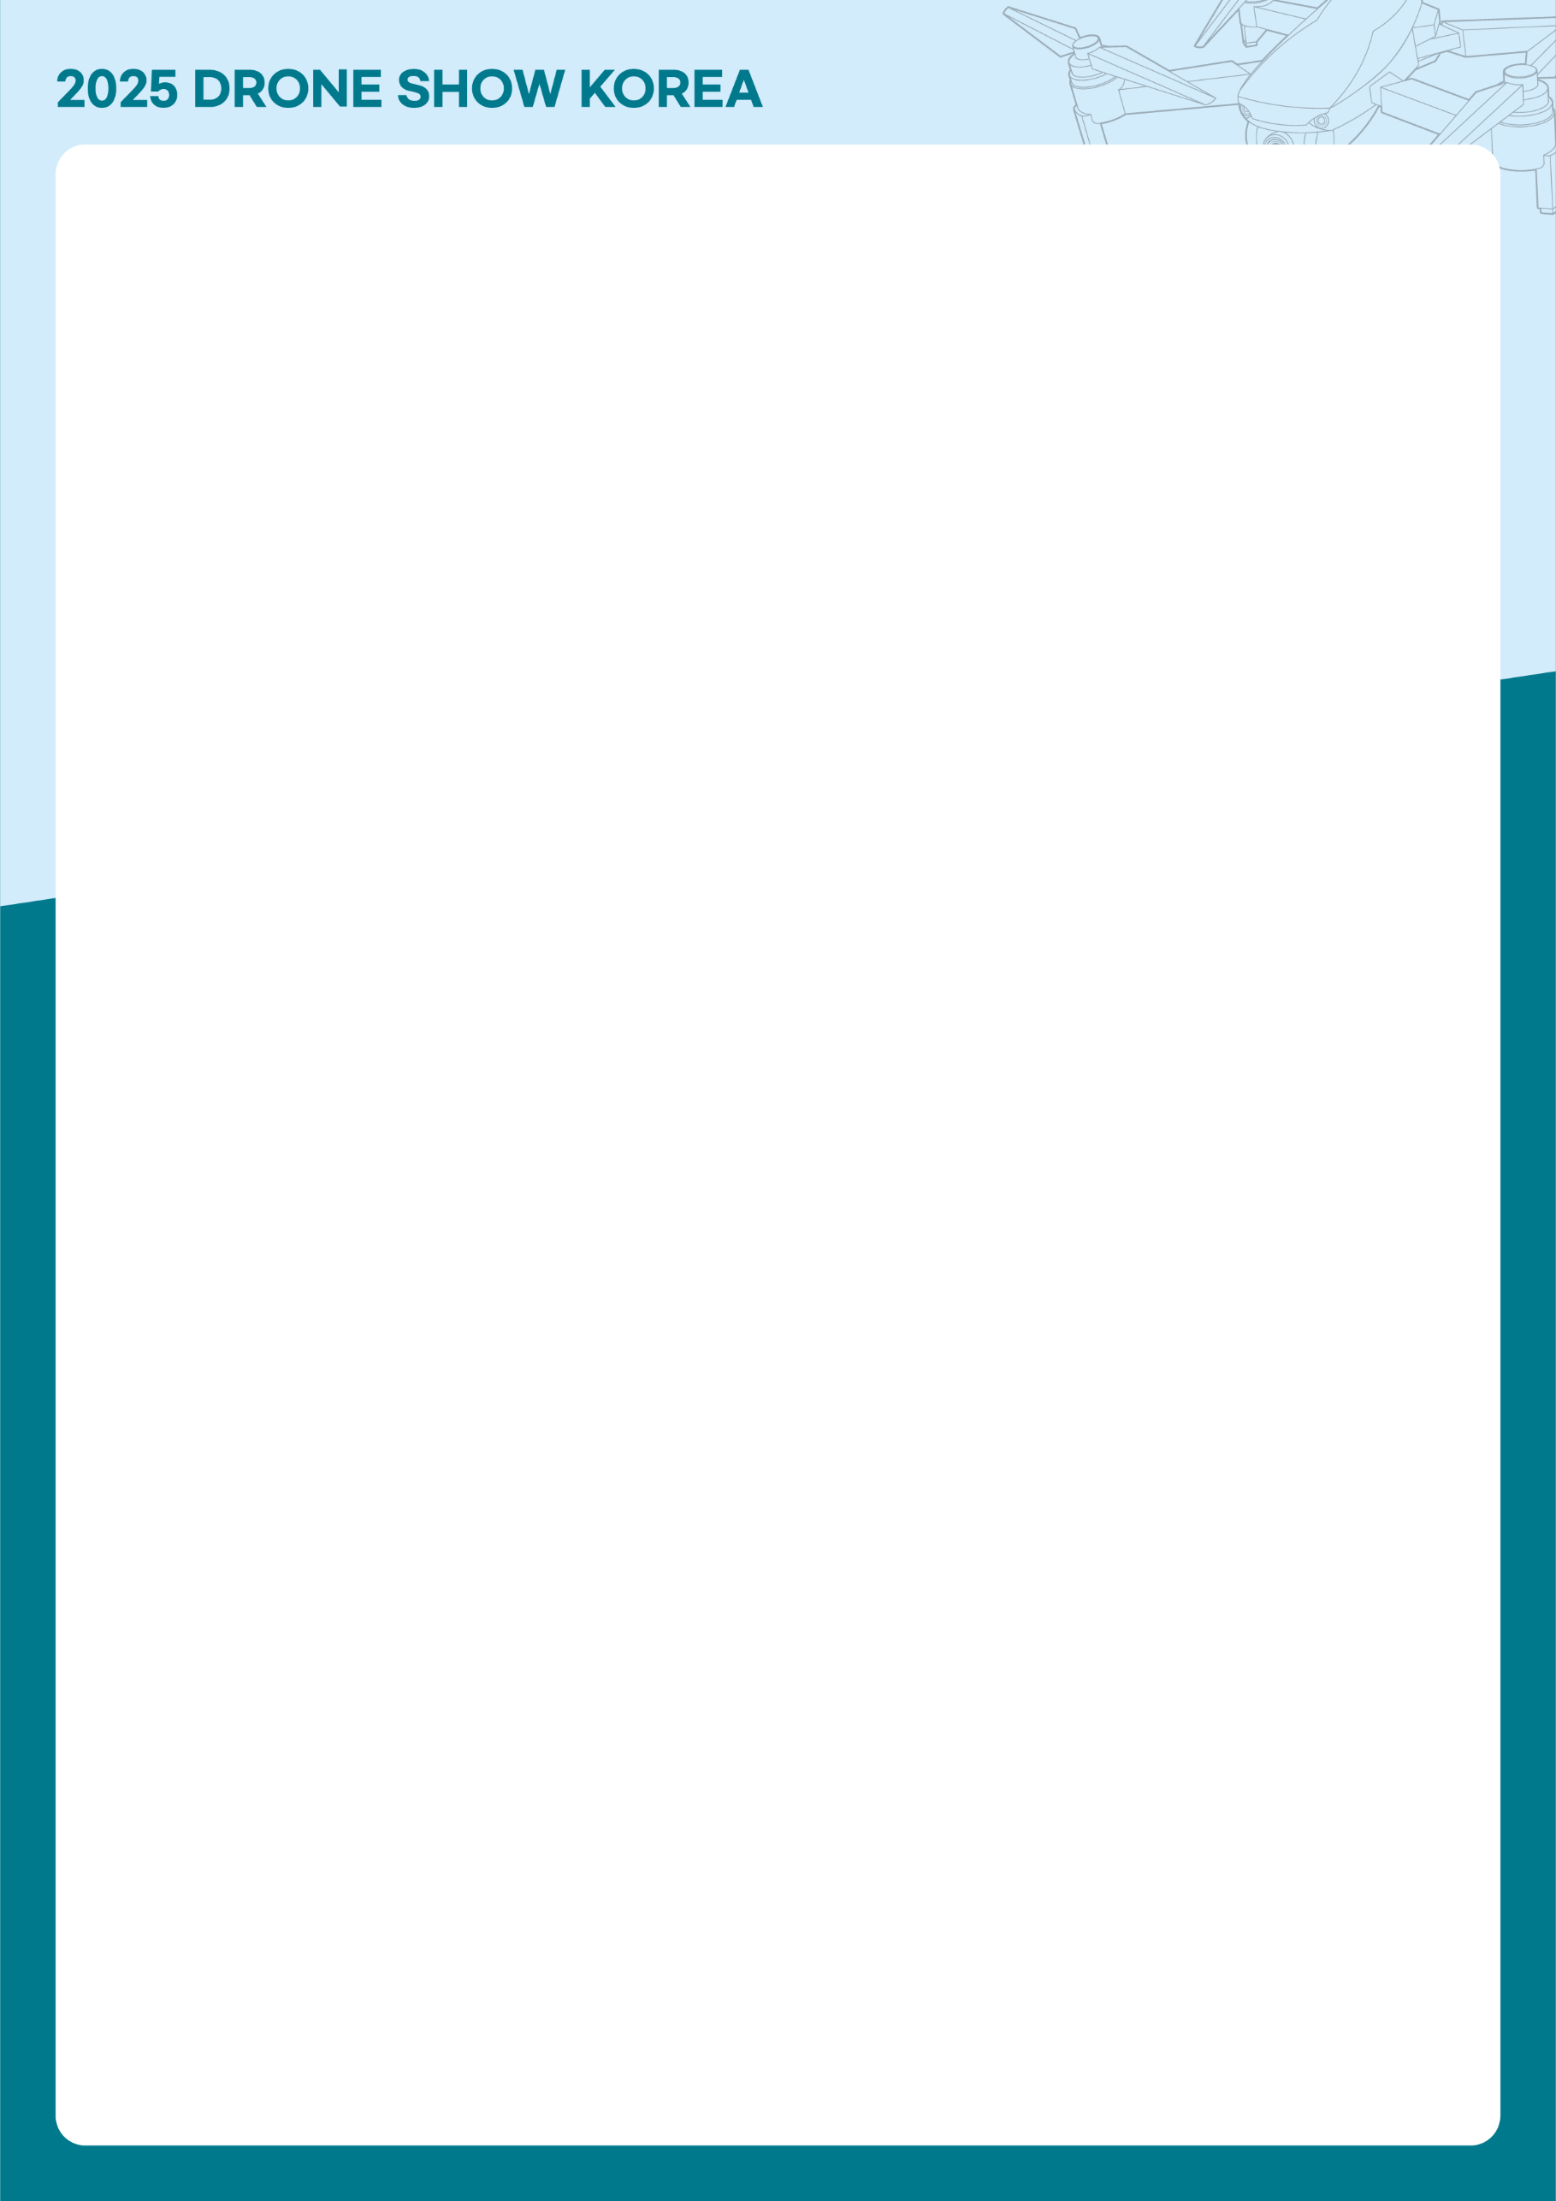

|  |
| --- |
| **DRONE SHOW KOREA 2025 Application Form** |

**Drone Show Korea Secretariat : +82-51-740-7409ㅣ Email :** [**droneshow@bexco.co.kr**](mailto:droneshow@bexco.co.kr)

**Website :** [**www.droneshowkorea.com**](http://www.droneshowkorea.com) **ㅣ Facebook :** [**www.facebook.com/droneshowkorea**](http://www.facebook.com/droneshowkorea)

**1. Exhibitor’s Information**

|  |  |  |  |  |  |  |
| --- | --- | --- | --- | --- | --- | --- |
| **Company Name** | |  | | | | |
| **CEO** | |  | | | | |
| **Address** | |  | | | | |
| **HOMEPAGE** | |  | | | | |
| **PERSON IN CHARGE** | **Name** |  | **Position** |  | **Tel.** |  |
| **E-mail** |  | | | **Mobile** |  |

|  |  |  |
| --- | --- | --- |
| **Type of your company (Multi selection available)** | | |
| □ Manufacturers of Drone  and/or Related Parts | □ System and Software | □ Service (Education, Finance, Investment, etc.) |
| □ Utilization  (Photography, Agricultural Drones, Measurement, Monitoring, etc.) | □ Organization (Drone Related Institution, Colleges, Government Departments) | □ Etc.____________________ |

**2. Booth Fee**

|  |  |  |  |  |
| --- | --- | --- | --- | --- |
| **Booth Type** | | **Booth Unit** | **Unit Price** | **Charge** |
| **Space only** | **1booth**  **(3mX3m)** | Booth | USD 2,000 / 1booth(9㎡) | USD ( ) |
| **Shell Scheme Booth** | **1booth**  **(3mX3mX2.4m)** | Booth | USD 2,500 / 1booth(9㎡) | USD ( ) |
| **Package booth**  **(block type)** | **Type A**  **(6mX3mX4m)** | Booth | USD 7,000 / 1booth(18㎡) | USD ( ) |
| **Type B**  **(6Mx6mX4m)** | Booth | USD 14,000 / 1booth(36㎡) | USD ( ) |
| **Type C**  **(9mX6mX4m)** | Booth | USD 20,000 / 1booth(54㎡) | USD ( ) |
| **Discount Information**   1. **Early Bird (until Aug. 30th 2024) : 10% off** 2. **Re-entry (Companies that participated in the DSK 2024) : 10% off** 3. **10 Booths and more : 10% off** | | | | USD ( ) |
| **Total** | | | | USD ( ) |

※ Minimum 2 booths(18㎡) are required to apply for ‘Space Only type booth’.

※ There is no ‘Early Bird Discount’ for package booth / Deadline for package booth application is 2024.12.13



**3. Payment**

|  |  |  |  |
| --- | --- | --- | --- |
| **How to apply** | **○ Fill out the Application Form**  **○ Submit the Form to “droneshow@bexco.co.kr”**  **○ Complete Payment within 2 weeks from the date that you received an invoice** | | |
| **Bank Name** | Busan Bank | **Account No.** | 113-2006-2877-00 |
| **Beneficiary** | BEXCO | **Swift Code** | PUSBKR2P |

**4. Booth Option**

|  |  |
| --- | --- |
| **Booth Type** | **Booth Option** |
| **Space Only** | **○** Only Space is provided.  **○** Booth construction should be done by permitted company by Korean Law and regulation of BEXCO. |
| **Shell Scheme**  **Booth** | **○** Floor carpet, Booth, Name Board, Spot light will be provided.  **○** Electricity : 1KW per booth  **○** A set of information desk (including 2 chairs), a set of round table (including 2 chairs)  ※ Only one set of round table is provided to each company regardless of the number of booths. |
| **Package booth** | **○** Please refer to the website guide (http://eng.droneshowkorea.com/sub02/sub02.php) |

**5. Facility Fee**

|  |  |  |  |  |  |
| --- | --- | --- | --- | --- | --- |
| **Type** | | **Unit Price** |  | **Type** | **Unit Price** |
| **Electricity** | **Single Phase (220V)** | USD 70 / KW |  | **Compressed Air** | USD 250 / EA |
| **Three Phase (380V)** |  | **Water & Drain** | USD 250 / EA |
| **24hours(220V/380V)** | USD 80 / KW |  | **LAN Cable** | USD 150 / PORT |

**6. Exhibitor’s Proposal**

If you want to get the chance of promotion, please select the type of your preferred promotion below and submit the details of your plan. To make specific plan, Drone Show Korea Secretariat will contact you.

|  |  |  |  |
| --- | --- | --- | --- |
| **Type** | | | |
| □ Demonstration of product | □ Experiential Events | □ Presentation | □ Etc. |

□ We understand this application becomes a binding contract when accepted by Drone Show Korea 2025.

□ We agree to abide by the General Information, Rules and Regulations of Drone Show Korea 2025.

**We hereby apply for participation in Drone Show Korea 2025 as stated above.**

**. . 202**

**CEO : (Signature)**



**Exhibition Terms and Conditions**

**1. DEFINITIONS**

- “Exhibitor” means any person, firm, company or organization who is identified on the front application.

- “Exhibition” means “Drone show Korea 2025”

- “Organizer” means BEXCO.

**2. BOOTH ALLOCATION**

- Organizer shall allocate the booth under the consideration of order of application and payment received, nationality, products and services to be displayed, booth size, the number of participation in Exhibition and any other reasonable standards.

- Organizer reserves the right to amend the floorplan or alter the exact location of the booths allocated to Exhibitor without incurring any liability to Exhibitor thereby.

**3. PARTICIPATION FEE PAYMENT**

A shell scheme booth is USD2,500/booth(9㎡), and space only is USD2,000/(9㎡). To apply for space only, minimum 18㎡ are required. Total participation fee must be paid within two weeks from the date that a participant submits application form to Organizer.

**4. PARTICIPATION FEE DETAILS**

Participation fee includes booth rental, 24hour security services, hall passage cleaning, promotion, etc.

**5. INSTALLATION AND REMOVAL**

Installation and removal of Exhibition facilities shall be completed within the designated period. Exhibitor shall pay Organizer for any loss incurred due to delay in installation or any removal damage to Exhibition Hall made by Exhibitor.

**6. PROVISION OF INFORMATION TO ORGANIZER**

Exhibitor is obliged to provide all information that could reasonably be expected to be of importance in connection with Exhibition such as products to be displayed, booth construction, public relations materials etc.

**7. OCCUPATION OF BOOTH AND STAFFING**

Exhibitor must staff their booth during Exhibition hour. Exhibit personnel may not stand in the aisles or hand out materials and must do so only within the allocated booth area. Organizer reserves the right to decline, prohibit or expel and exhibit item or service which is inappropriate or out of keeping with the character of Exhibition.

**8. LIABILITY (INSURANCE, SECURITY AND SAFETY)**

Exhibitor must effect at his/her own cost full indemnity insurance against comprehensive general liability and all other usual risks in respect of loss, damage or accident. Organizer will arrange a general site security during Exhibition but will accept no liability for any loss or damage. Exhibits, fabrics and other decorative materials must have proven flame resistance in accordance with Fire and Safety Regulations of BEXCO. Organizer may restrict booth construction or displays when necessary.

**9. CANCLEATION BY EXHIBITOR**

Exhibition participation contract may be terminated by Organizer when Exhibitor either wishes to cancel his/her booth booking or fails to meet any of the payment obligations on the participation contract, then Organizer reserves the right to cancel the contract.

- Until 20th Jan. 2020 : 50% of participation fee will be paid as cancelation fee

- After 20th Jan. 2020 : 100% of participation fee will be paid as cancelation fee

**10. CANCLELATION BY ORGANIZER**

Organizer may cancel all or any part of Exhibition for any reason beyond its reasonable control, in which case Organizer will refund to Exhibitor a pro rata portion of any participation fees already paid to Organizer.

However, in case of compelling reasons in particular force majeure, Organizer is entitled to postpone, shorten, partially or completely close or to cancel Exhibition, if and as far as the reasons are not in Organizer’s responsibility. In this case, Exhibitor is not entitled to receive any reimbursement, and Exhibitor shall not have any claim against Organizer in respect of any loss or damage.

**11. SUPPLEMENTARY REGULATION**

Organizer reserves the right to add or amend the terms and conditions when necessary. Exhibitors shall accept the additions, amendments and the regulation of BEXCO, and consider them as part of this “Exhibition Terms and Conditions”.

**12. SETTLEMENT OF DISPUTES**

Any disputes that might occur between Organizer and Exhibitor concerning this “Exhibition Term and Conditions” or mutual rights and obligations shall follow the ruling of Korean Commerce Arbitration Board location in Busan and its ruling is final and carries legal binding force to both parties.

**8. LIABILITY (INSURANCE, SECURITY AND SAFETY)**

Exhibitor must effect at his/her own cost full indemnity insurance against comprehensive general liability and all other usual risks in respect of loss, damage or accident. Organizer will arrange a general site security during Exhibition but will accept no liability for any loss or damage. Exhibits, fabrics and other decorative materials must have proven flame resistance in accordance with Fire and Safety Regulations of BEXCO. Organizer may restrict booth construction or displays when necessary.

**9. CANCELLATION BY EXHIBITOR**

Exhibition participation contract may be terminated by Organizer when Exhibitor either wishes to cancel his/her booth booking or fails to meet any of the payment obligations on the participation contract, then Organizer reserves the right to cancel the contract.

- Until 26th Jan. 2025 : 50% of participation fee will be paid as cancellation fee

- After 27th Jan. 2025 : 100% of participation fee will be paid as cancellation fee

**10. CANCELLATION BY ORGANIZER**

Organizer may cancel all or any part of Exhibition for any reason beyond its reasonable control, in which case Organizer will refund to Exhibitor a pro-rata portion of any participation fees already paid to Organizer.

However, in case of compelling reasons in particular force majeure, Organizer is entitled to postpone, shorten, partially or completely close or to cancel Exhibition, if and as far as the reasons are not in Organizer’s responsibility. In this case, Exhibitor is not entitled to receive any reimbursement, and Exhibitor shall not have any claim against Organizer in respect of any loss or damage.

**11. SUPPLEMENTARY REGULATION**

Organizer reserves the right to add or amend the terms and conditions when necessary. Exhibitors shall accept the additions, amendments and the regulation of BEXCO, and consider them as part of this “Exhibition Terms and Conditions”.

**12. SETTLEMENT OF DISPUTES**

Any disputes that might occur between Organizer and

Exhibitor concerning this “Exhibition Term and Conditions”

or mutual rights and obligations shall follow the ruling of

Korean Commerce Arbitration Board located in Busan and

its ruling is final and carries legal binding force to both

parties.

**8. LIABILITY (INSURANCE, SECURITY AND SAFETY)**

Exhibitor must effect at his/her own cost full indemnity insurance against comprehensive general liability and all other usual risks in respect of loss, damage or accident. Organizer will arrange a general site security during Exhibition but will accept no liability for any loss or damage. Exhibits, fabrics and other decorative materials must have proven flame resistance in accordance with Fire and Safety Regulations of BEXCO. Organizer may restrict booth construction or displays when necessary.

**9. CANCLEATION BY EXHIBITOR**

Exhibition participation contract may be terminated by Organizer when Exhibitor either wishes to cancel his/her booth booking or fails to meet any of the payment obligations on the participation contract, then Organizer reserves the right to cancel the contract.

- Until 20th Jan. 2020 : 50% of participation fee will be paid as cancelation fee

- After 20th Jan. 2020 : 100% of participation fee will be paid as cancelation fee

**10. CANCLELATION BY ORGANIZER**

Organizer may cancel all or any part of Exhibition for any reason beyond its reasonable control, in which case Organizer will refund to Exhibitor a pro rata portion of any participation fees already paid to Organizer.

However, in case of compelling reasons in particular force majeure, Organizer is entitled to postpone, shorten, partially or completely close or to cancel Exhibition, if and as far as the reasons are not in Organizer’s responsibility. In this case, Exhibitor is not entitled to receive any reimbursement, and Exhibitor shall not have any claim against Organizer in respect of any loss or damage.

**11. SUPPLEMENTARY REGULATION**

Organizer reserves the right to add or amend the terms and conditions when necessary. Exhibitors shall accept the additions, amendments and the regulation of BEXCO, and consider them as part of this “Exhibition Terms and Conditions”.

**12. SETTLEMENT OF DISPUTES**

Any disputes that might occur between Organizer and Exhibitor concerning this “Exhibition Term and Conditions” or mutual rights and obligations shall follow the ruling of Korean Commerce Arbitration Board location in Busan and its ruling is final and carries legal binding force to both parties.